Task 1: To Retrieve Current Directory, Display Path, Process Exit Requests, Cleanup Resources, Save State, Verify Correct Behavior.
Code:
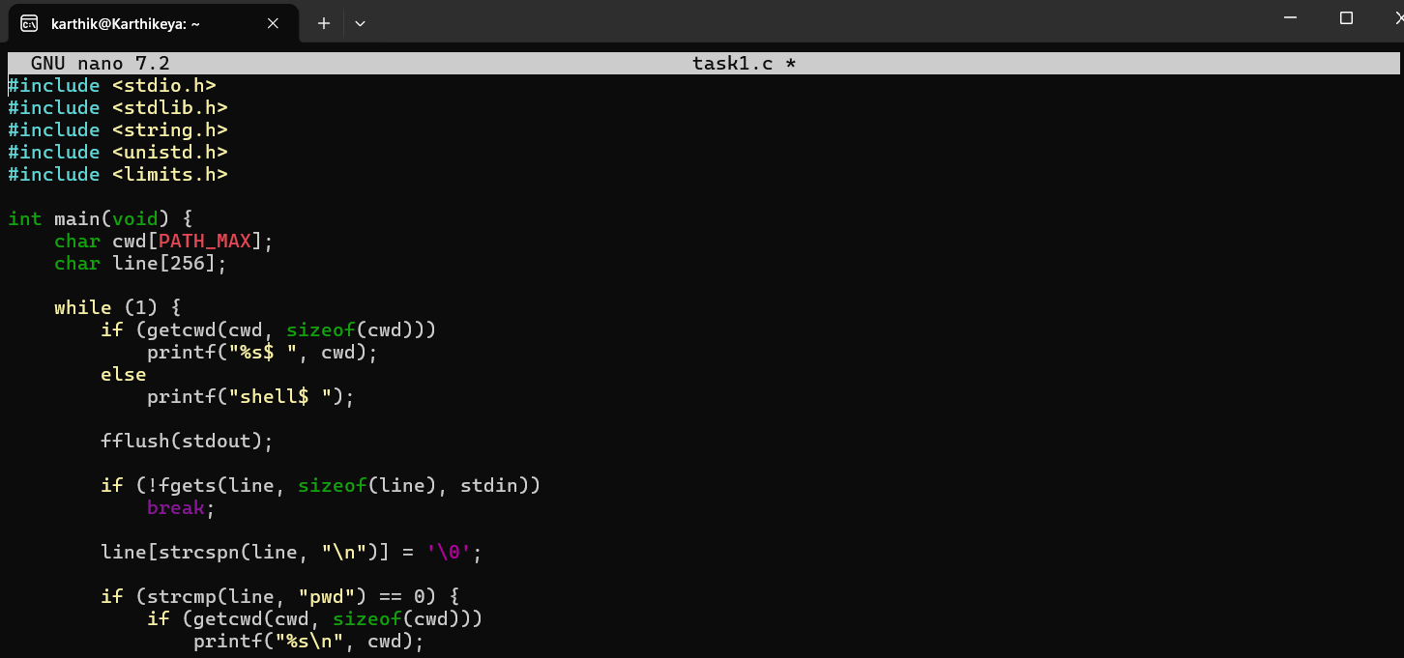

Output:
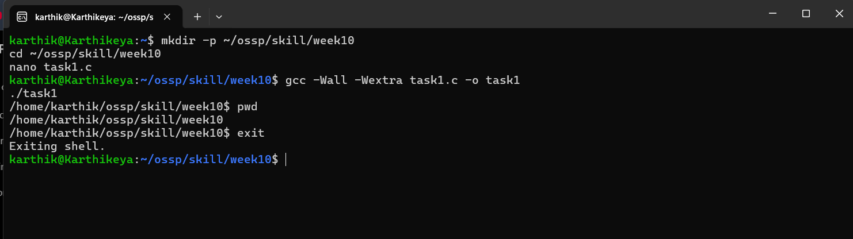

Task 2: To Parse Export Syntax, Update Environment Variables, Validate Names, Handle Existing Variables, Export to Child Processes, Test Functionality.
Code:
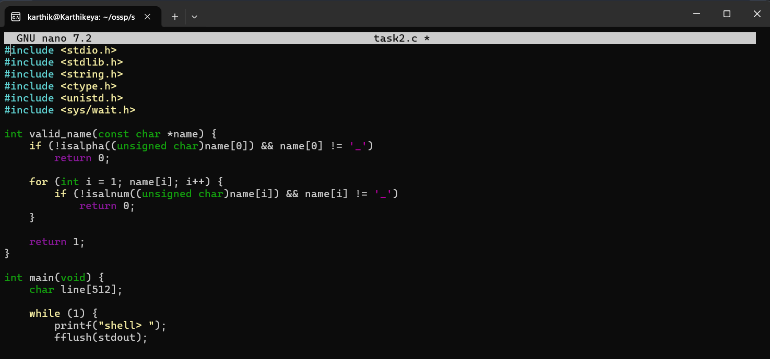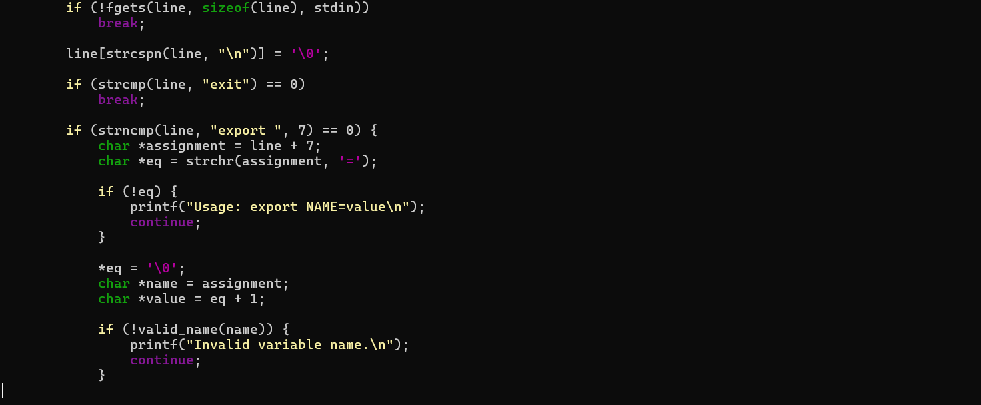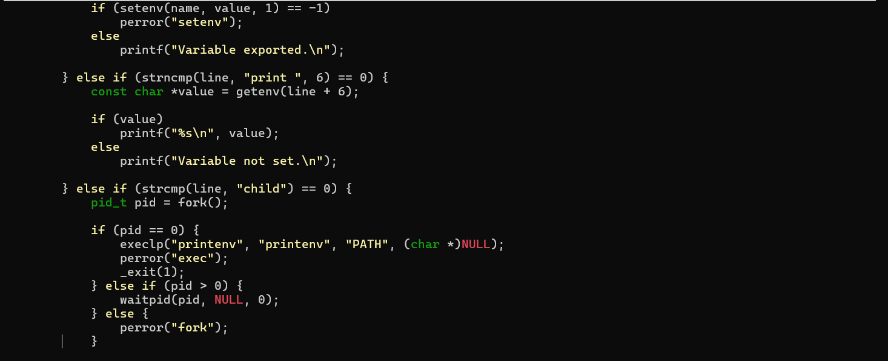

Output:
